12:26:48 Email was triggered for: Success
12:26:48 Sending email for trigger: Success
12:26:52 Sending email to: xxxxxx@xxxxx.com
12:26:52 [WS-CLEANUP] Deleting project workspace...[WS-CLEANUP] done
12:26:52 Finished: SUCCESS

The Console log shows that only one email is triggered with a success trigger. This is an expected result.
However, there were multiple emails being sent with the same content, subject and at same time.

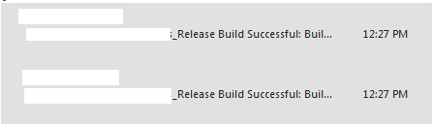
To make sure that either of the emails are getting triggered for only success event, I gave single email address for success and 2 emails for fixed. As you can see, email is being triggered only in success event and my emails also have only one recipient in To: address.
Below is the email configuration:

